# Introducing how to play

About this game

Well this game is so simple only one thing you should know about it, is when you select or click on a light, that light and lights which is located on up, down, left , right and itself change their attribute for example: if one of them was on and you clicked one of those in its area, it become off and vice versa.

Do your best to kill all lights.

How to play game

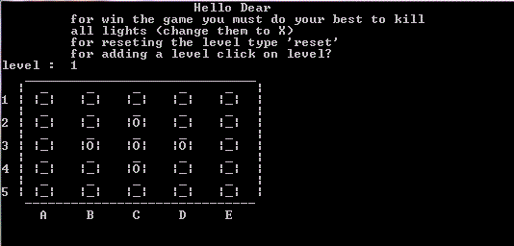As you see blew

O means that lamp is on and you should kill it.

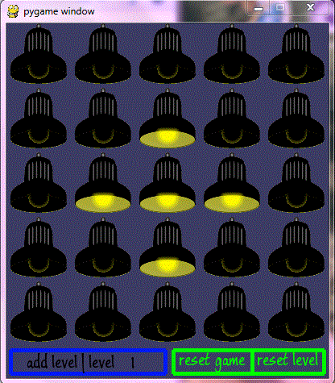and this is the game with pygame interface

you can restart the game or level or adding a level by touching the buttons

you can touch the light to kill it.